**Year wise Growth of EV Market**

The market for electric vehicles in India was estimated to be worth USD 220.1 million in 2020, and from 2021 to 2030, it is anticipated to increase at a CAGR of 94.4%. During the course of the forecast period, market expansion is predicted to be fueled by the alluring incentives being granted by the Indian government on the manufacturing and purchase of electric vehicles to promote the adoption of electric vehicles. Sales of both passenger and commercial automobiles fell significantly overall in 2020 as a result of the COVID-19 pandemic outbreak. In India, however, there was no change in the sales of electric vehicles. An important aspect boosting the electric vehicle market in India is the post-lockdown sale of pure and hybrid electric automobiles.

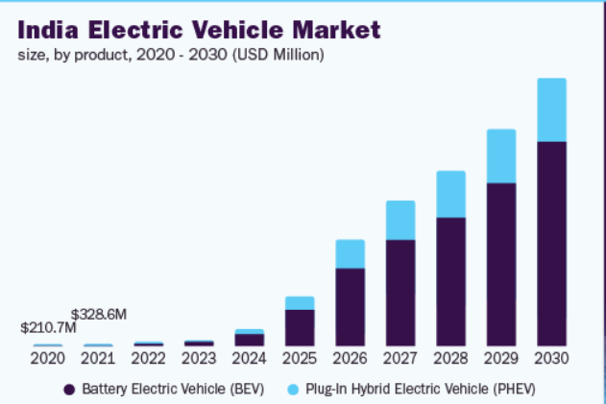

Fig: Growth of India EV market

The growth of electrification in vehicles is anticipated to be accelerated by the rising costs of conventional gasoline. The government's strict pollution regulations and Indian customers' rising environmental consciousness are also anticipated to increase demand for electric vehicles. Also, substantial attempts have been made by Indian manufacturers to include electrified vehicles in their product lineup, including Tata Motors and Mahindra & Mahindra Ltd. This is expected to influence Indian consumers to choose electric vehicles. The growth of the electric vehicle market in India during the anticipated term is encouraged by all of these factors.

India is regarded as one of the leading nations in the global auto sector. A number of businesses are actively setting up factories in India. For instance, Dana TM4 Inc. declared plans to build a manufacturing facility in Pune, India, in September 2020. The new 4,600 square metre plant would manufacture electric motors, vehicle control systems, and Dana TM4 low- to high-voltage inverters. The Phase-II of the Faster Adoption and Manufacturing of Electric Vehicles (FAME) programme of the Indian government aims to accelerate the uptake of electric mobility while also fostering the growth of its manufacturing eco-system. The following pillars will be used to implement Phase-II of the FAME scheme: encouraging the demand for EVs; conducting awareness campaigns, including publicity and information, education, and communication (IEC) efforts; and developing a charging infrastructure.

Almost 96% of the market's total revenue was contributed by the BEV segment in 2020. The segment's dominant market share can be attributed to consumers' growing preference for EVs over ICE cars and regulations on vehicle CO2 emissions. BEVs have the potential to drastically lower vehicle emissions as well as the long-term cost of ownership. Over the projected period, it is also anticipated that improvements in battery technology and falling lithium-ion battery prices will fuel demand for BEVs.

Hyundai Motor India, Tata Motors, Mahindra & Mahindra Ltd, Audi AG, BMW AG, MG Motor India Pvt. Ltd., and Olectra Greentech Ltd are some of the major companies that dominated the industry in 2020. These market participants provide a variety of electric vehicles, such as electric buses, light commercial vehicles, and passenger automobiles. The corporations are putting a lot of effort into releasing cutting-edge, technologically superior products on the market. To strengthen their position in the market, they are also exploring strategic initiatives like mergers and acquisitions, strategic partnerships, and collaborations. For instance, the ride-hailing service Uber announced a cooperation with India's Lithium Urban Technologies, a fleet operator for electric vehicles, in October 2020. The collaboration envisages the two companies deploying over 1,000 electric vehicles for Uber India’s Rentals and Premier ser Some of the prominent players operating in the India electric vehicle market are :

Audi AG

BMW AG

Hyundai Motor India

Jaguar Land Rover Limited

Mahindra & Mahindra Ltd

Mercedes-Benz AG

MG Motor India Pvt. Ltd.

Olectra Greentech Limited

Tata Motors

Toyota Motor Corporation